* When a computation of a very high scale is required then Azure batch jobs are used.
* <https://docs.microsoft.com/en-us/azure/batch/batch-technical-overview>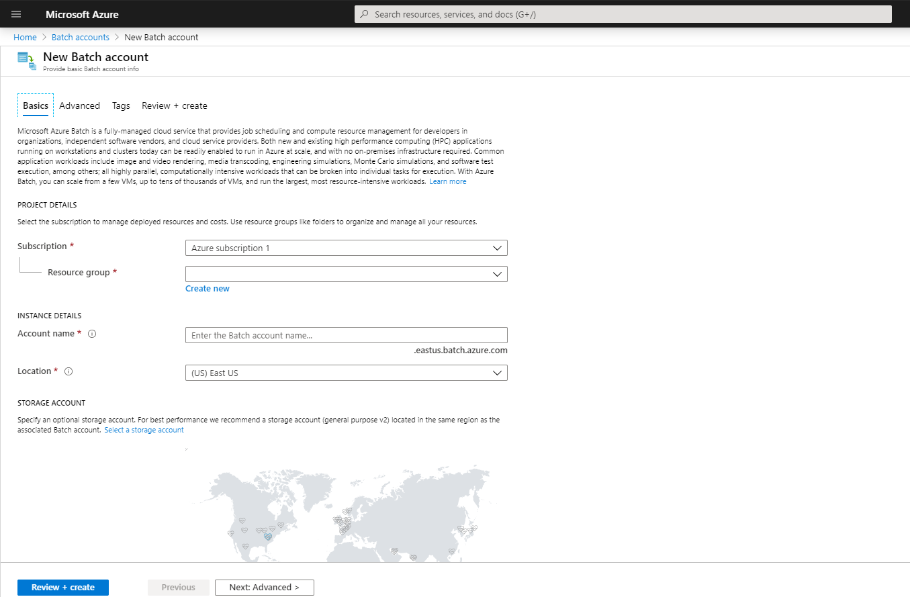
* Azure Batch jobs require batch accounts to proceed with it.
* Batch account name: aztusbatchaccount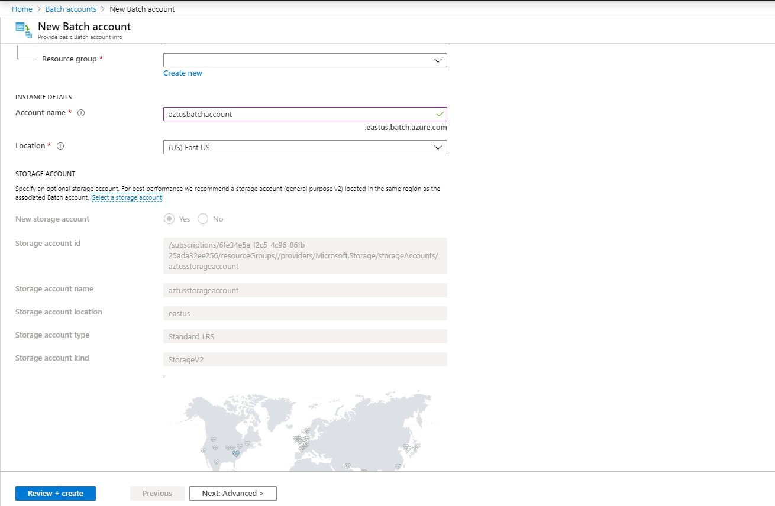
* Review and create a batch account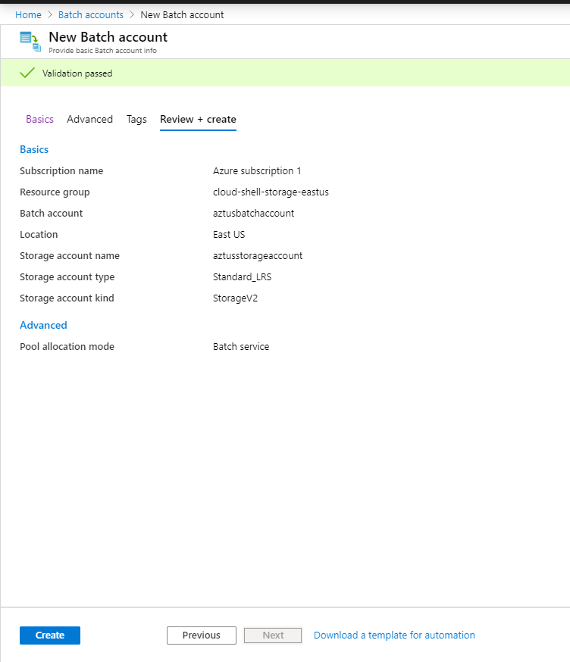
* Go to azure sample batch code to see what it supports 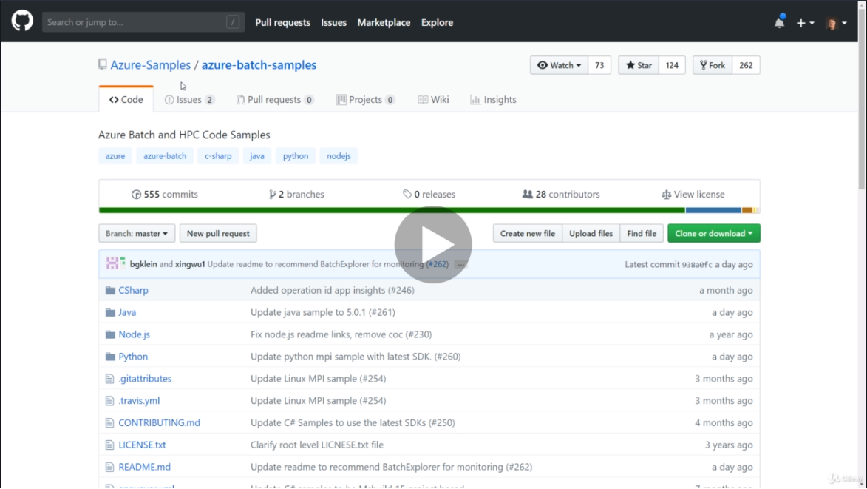
* Read documentation and mandatory pre-requesite about azure batch account <https://github.com/Azure-Samples/azure-batch-samples>
* Try and run one of the language hello world program to execute a batch job.

Do a demo for it.

We can run the program woth appropriate batch account, storage account and azure account settings and run it, Download the batch explorer software to observe it.